**Greek Drama**

**BACKGROUND NOTES**

The beginnings of the theatre in the Western World can be traced back to the Ancient Greeks. They laid the foundations from which many later developments were to emerge. Even today Greek plays are still performed and remain influential.

**Dramatic Festivals**

Greek drama had its origins in the worship of the gods and in particular Dionysus; god of vegetation and wine. Greek drama was intimately connected with religion and the main occasion for the performance of plays would have been at religious festivals. One of the most important dramatic festivals was the City Dionysia at Athens. This festival, held in honour of Dionysus, was given over to the performance of plays including a three day competition devoted to tragedy.

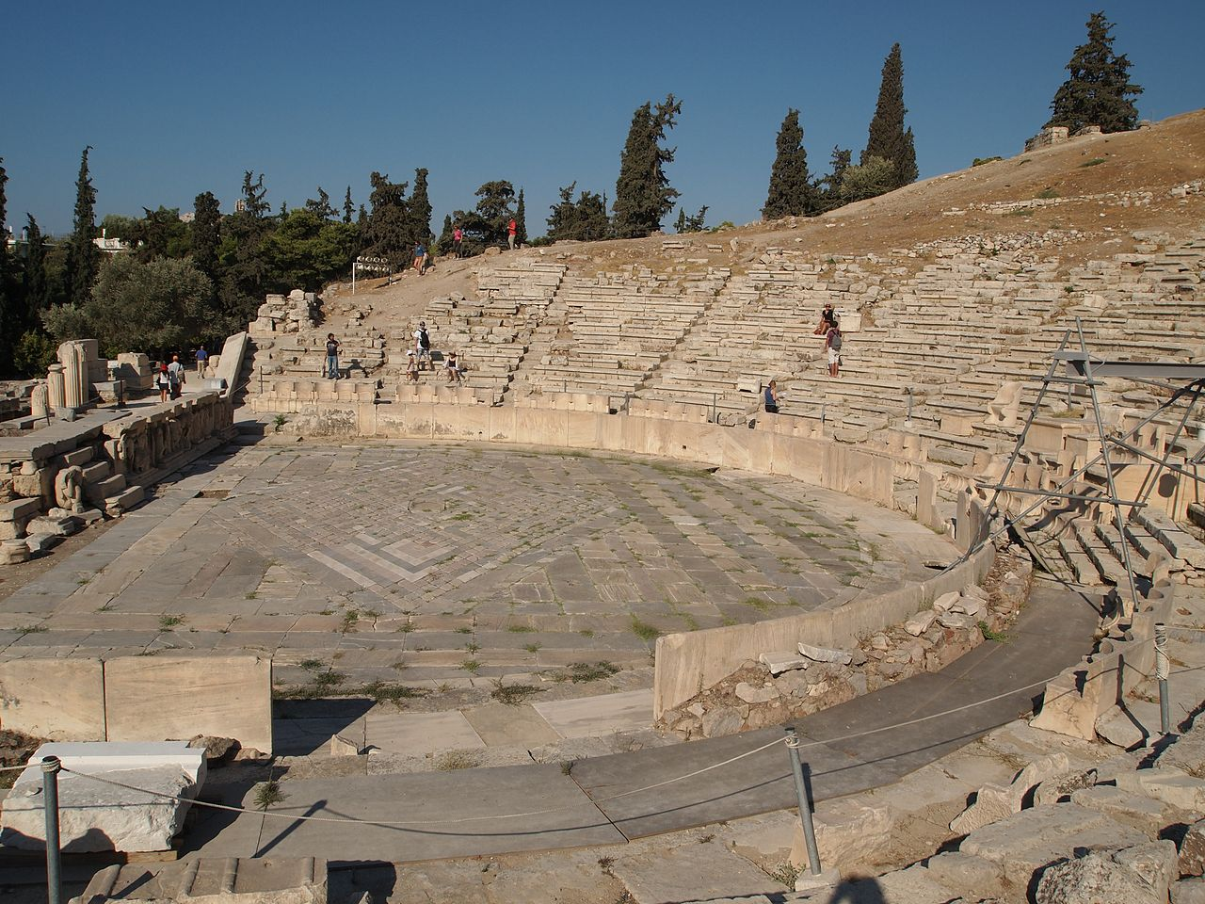

Theatre of Dionysus on the south slopes of the Acropolis

On each of the three days of the tragic competition an individual dramatist would present four plays to the audience; usually three tragedies and one more light-hearted play called a Satyr play. These performances would last all day from sunrise to sunset. At the end of the three days a winner had to be chosen by ten judges who had been appointed by lot from a list of suitable candidates. By the mid-fifth century BC prizes were given for the best dramatist, choregos (chorus master) and tragic actor. Originally the prizes were ivy wreaths, later more substantial prizes, including some financial reward, were presented.

**The Audience**

The audience for Greek plays seems to have consisted of a broad cross-section of society. At the City Dionysia the priest of Dionysus and Athens’ magistrates attended the plays, which underlines the religious and civic importance of this event. But the majority of the audience seems to have been made up of ordinary Athenian citizens, perhaps even including women. The theatre of Dionysus at Athens was capable of holding up to 15,000 people and dramatic performances were popular events, attracting large numbers. Spectators could take their own cushions and food for the day-long performances. Food and drink was also sold at the theatre. Audiences were far more rowdy than modern ones; we know that they hissed, clapped, shouted and even threw food at the performers. However such behaviour does not preclude an appreciation of the plays.

**Greek Plays**

Greek drama can be divided into three main categories: tragedy, comedy, and Satyr plays. All three types were written in verse and involved a chorus which sang and danced during the play. However there are some basic differences between these categories.

Tragedies were serious plays, usually based on one of the many Greek myths, and generally with an unhappy ending. The hero or heroine suffers in some way and often brings disaster on themselves in a state of sorrow or anger, or by offending some god. Sometimes the chorus’s role is to offer direct comment on these events and to fill in some of the background, but this was not always the case; some choral odes are only very loosely connected to the plot.

The best known tragedians in the Ancient world were three Athenians writing in the fifth century BC. They were Aeschlyus, Sophocles and Euripides. Some of their works have survived and are still performed, though these only represent a fraction of each poet’s output.

Comedy, unlike tragedy, was written with the intention of making the audience laugh. Furthermore comedy, at least in the fifth century BC, was based on contemporary events. The poet Aristophanes, for example, wrote satirical plays attacking Athenian politicians and also the state’s policy during the Peloponnesian War. Comedies are known to have been performed during the City Dionysia, but the most important festival for comic plays at Athens was the Lenaia. This was another festival held in honour of Dionysus, at which comic poets could compete in a similar competition to the one for tragedies at the City Dionysia.

The final category of play known from Greek drama is the Satyr play; so called because the choruses dressed as Satyrs. These were mythical followers of Dionysus who were half man, half horse. In these plays stories from myth were presented in a grotesque and distorted way. They were usually performed after the three tragedies at the City Dionysia.

**Actors**

All the participants in Greek drama were men; even female roles were taken by male actors. Apart from the chorus, which in tragedies consisted of twelve or fifteen men, there were, by the mid fifth century BC, three other actors. These usually played more than one role and therefore had to be involved in a number of costume changes.

Costumes consisted of an ankle length robe, known as a chiton, and on occasion a cloak, called a himation. Both of these were often very colourful and richly patterned. Masks were another feature of an actor’s costume. In the fifth century BC they were made to cover the whole head and included a wig. They were made from linen, which was then covered in plaster and painted. Each mask’s hair and facial expression would have been carefully designed to suit the character it was intended to represent.

Greek plays were performed in large, open air theatres, so acting would have been heavily stylised, with bold and obvious gestures. The more subtle nuances we might expect to see from an actor would have been lost for the majority of an audience**.**

**Theatres**

Greek theatres were open air structures, often built on hillsides so that the seats of the auditorium could follow the natural slope of the hill. In fact early audiences probably just sat on the hillside; it was only later that wooden seats were set up. Later still permanent stone auditoria were built for some theatres. The bowl-shape of Greek theatres, set in hillsides, was obviously designed to enhance their acoustics.

In a similar way the rest of an early Greek theatre would have been very simple. There would have been an orchestra, a round area where the chorus of Greek plays danced, and a tent for the actors to change their costumes in. Some theatres eventually had a stage building, known as the scene, which included the set as well as the stage. Like the auditorium this was originally a wooden structure.

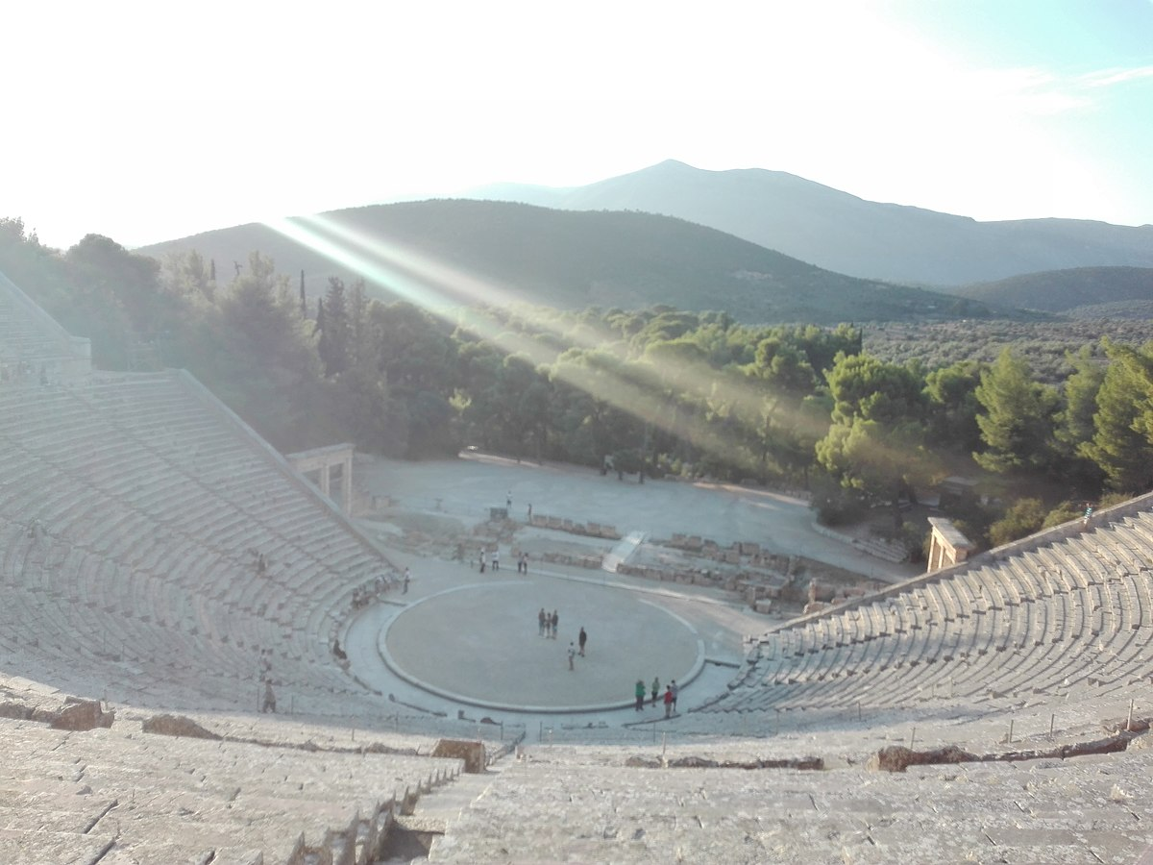

The theatre at Epidaurus